|  |  |
| --- | --- |
| **Project** | Customer name – Project name |
| **Title** | Custom Plugin - Plugin name |
| **Customer Delivery Date:** | dd/mm/yyyy |

Version Control

|  |  |  |  |
| --- | --- | --- | --- |
| **Version** | **Date** | **Author** | **Description** |
| 1.0 | 28/08/2019 | Nishant Zunzunwala \ Mustafa Shaikh | Plugin to get data from RFID reader having different antennas. |
|  |  |  |  |

# General Description

* Plugin to get data from RFID reader having different antennas.
* Plugin gets data from different antennas which are connected in TCP/IP.

# Plugin Presentation

* Plugin takes IP address and Antenna Id as user input.
* IP Address is the IP of the RFID reader. Using IP Plugin connects with the selected RFID Reader in the network.
* Antenna Id is used to get the RFID reading from the specific antenna of the RFID reader. In this case it will be different workstation Id.
* Using IP address, Plugin first connect to RFID reader. After successful connection RFID reader goes into reader mode.
* Whenever selected antenna detects RFID tag, Plugin reads ID of RFID tag and shows RFID tag ID.
* After successful detection of RFID tag Plugin disconnect RFID reader.

# Plugin Parameters

* Description of the parameters of the plugin :
  + IP Address: IP address is unique address of RFID reader for connection.

For Example: 192.168.0.51

* + Antenna Number: It is number of antenna from different 4 antennas.

For Example: 2

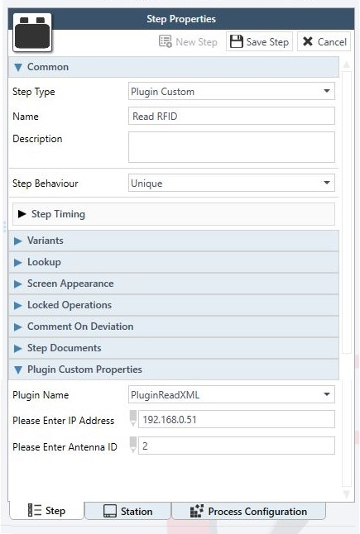

# Plugin Working Screenshots

* Description of the screenshot of the plugin :
  + 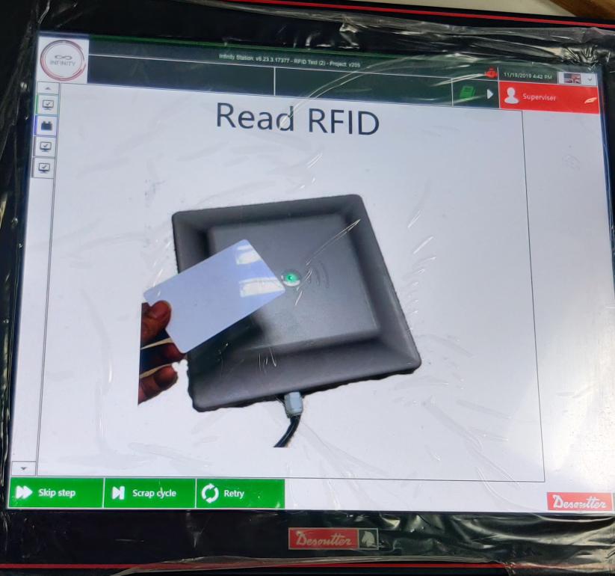Plugin in read mode and waiting for RFID tag to be read.

* + 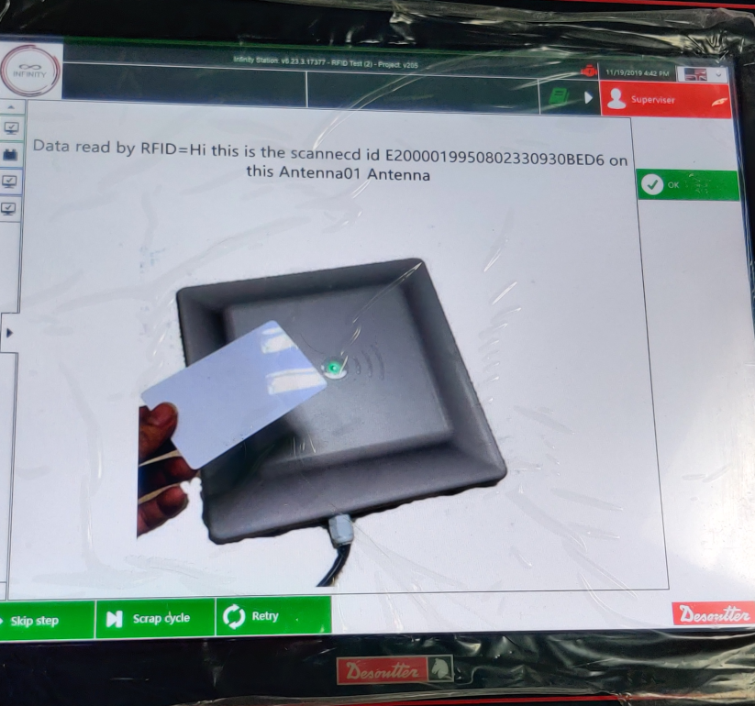Plugin detected RFID tag and displayed RFID tag id with respected antenna number.